
Buffalo Chicken
Chicken breast or thighs
Hot pepper sauce

Ghee, coconut oil or butter
soy sauce.
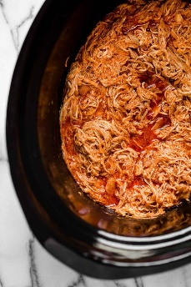
Garlic powder
Cayenne –
Baked sweet potatoes
Ranch dressing

How To Make Slow Cooker Buffalo Chicken
Place chicken in a slow cooker set on low.
In a small saucepan on medium-high heat, combine the hot sauce, soy sauce garlic powder, and optional cayenne. Stir together and heat until ghee is melted.
Pour sauce into the slow cooker.
Cook for 4-6 hours on low or until chicken is tender.
Remove chicken from slow cooker and shred with two forks. Return shredded chicken to slow cooker and toss with sauce.
Turn slow cooker to warm (or remain on low) until ready to serve.
Serve chicken in baked sweet potatoes and drizzle with buffalo sauce

